Ideation Phase
Empathize & Discover
Date | 07 September 2026
Team ID
Project Name | Automated Network Request Management in ServiceNow
Maximum Marks | 4 Marks

Empathy Map Canvas:
An empathy map captures knowledge about a user's behaviours and attitudes. For this project, the primary persona is a Network Requester / Employee who needs to request network access or connectivity through ServiceNow. The map considers the user's goals, challenges, thoughts, feelings, actions, pains, and expected gains.
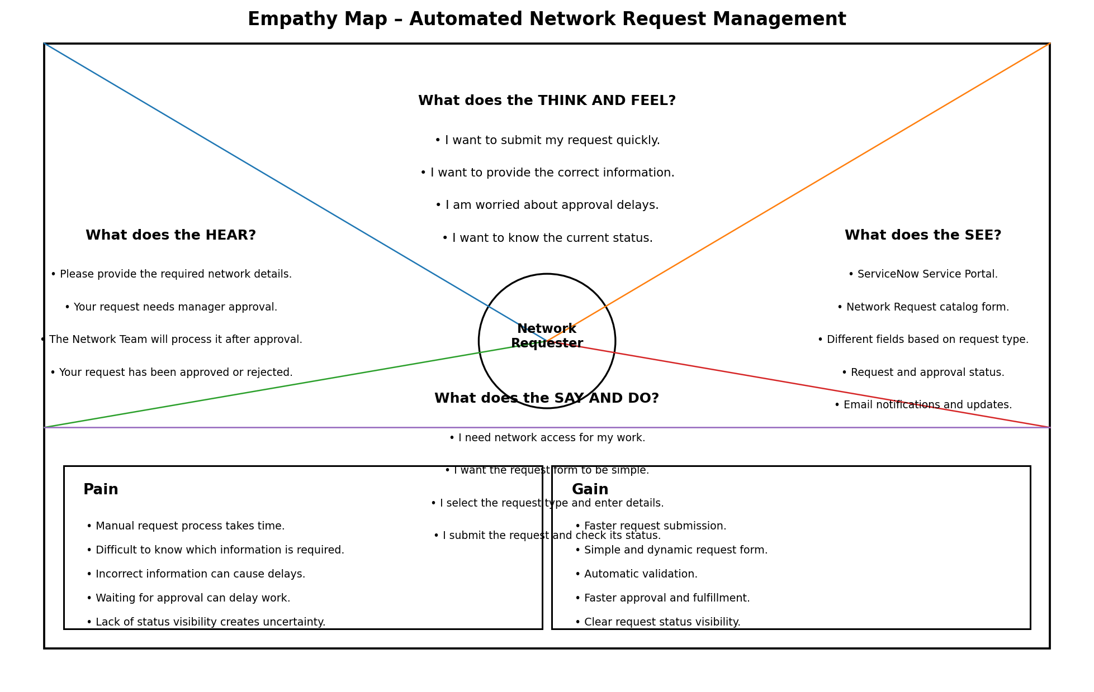
Figure 1: Empathy Map for the Network Requester / Employee

Persona Goal: Make the network request process simple, fast, and transparent for employees.

Key User Needs:
- Submit a network request easily.
- Provide the required network information correctly.
- Receive manager approval without unnecessary delay.
- Track the request and approval status.
- Know when the requested network service is completed.

Reference: Mural – Empathy Map Canvas (as shown in the supplied template).

